DES KEENAN INDIVIDUAL GRANT
APPLICATION FORM

IMPORTANT INFORMATION

- This application form is for individual applicants who reside in Chalkhill and live within the CCTF area of benefit (please refer to the map at the bottom of the form).

- Please read the Chalkhill Community Trust Fund (CCTF) Funding Criteria and Guidelines before completing the application form. It will help you decide whether you are eligible for the grant and assist you in completing the application form.

- Each Des Keenan Individual grant application must include a signed letter of support from your Housing Officer, Support Worker, Counsellor, nurse, CAB Advisor, Employment Officer, GP or Key Worker. Your application will not be considered without this letter of support.

- The normal limit for individual grants is £250. The Trustees may award an amount up to £500 if they believe special circumstances apply.

- Des Keenan Individual grant awards will be made directly to the third-party service provider, shop, organisation or supplier. Funds will not be deposited into an individual’s bank account nor be handed directly to applicants in cash or cheque.

- If you require a copy of the Funding Criteria and Guidelines, or further information and assistance, please contact Aminata Coulibaly, CCTF’s Administrator on 07415166652, or email: CCTFContact@gmail.com, or by post FAO Aminata Coulibaly, Chalkhill Community Trust Fund, c/o The Chalkhill Community Centre, 113 Chalkhill Road, Wembley, HA9 9FX.

- Completed applications should be sent to the details listed in 6) above.

- Privacy Statement
Any personal information you provide in this application will be used only to assist with the administration and assessment of your application and in publishing results of approved grants. Use of the information provided will be restricted to the Chalkhill Community Trust Fund (CCTF) board and parties acting on behalf of the CCTF. Individuals have the right to check and correct any personal information held by the CCTF.

PLEASE WRITE IN CAPITAL LETTERS

(a) Applicant details

Name:

Address &
Post Code:

Phone:

Email:

(b) Support / referral agency

Name:

Job Title

Organisation

Address &
Post Code:

Phone:

Email:

(c) Grant amount

How much money are you asking for? | £

(d) Summary of your request

Tell us in only one sentence what you want the money to pay for.

(e) Why you need this help ?

Please explain what your circumstances are and why you need help. Give as much detail and information as you can. Remember to attach copies of any supporting documents. Feel free to use additional sheets if you need to.

(f) Declaration
In making this funding application I declare that:
- To the best of my knowledge the information I have provided is true and correct
- I will comply with any reasonable request from CCTF to monitor how the money is spent
- I acknowledge that any decision made by the Chalkhill Community Trust Fund is final. I accept that no reasons for such decision will be given, nor will any further correspondence be entered into.

Signature: | Date:

(g) Completed applications:
should be sent to CCTF via email –CCTFContact@gmail.com or by post to Chalkhill Community Trust Fund, c/o The Chalkhill Community Centre, 113 Chalkhill Road, Wembley, HA9 9FX. For the attention of Aminata Coulibaly.

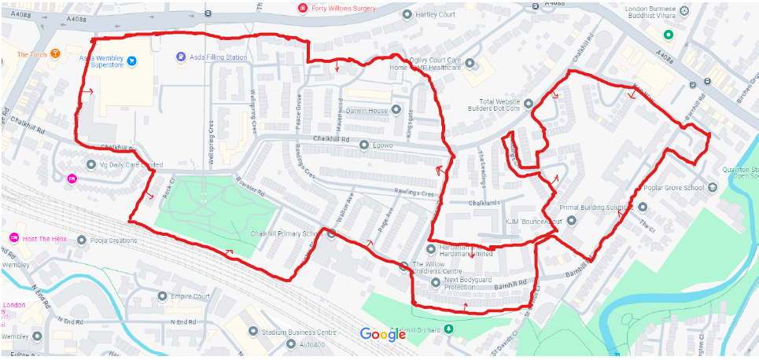
Map of the CCTF Area of Benefit

