CCTF Funeral Grant Form

This one-off grant, provided by the Chalkhill Community Trust Fund, assists residents of the Chalkhill Estate living within the CCTF area of benefit (please refer to the map at the bottom) with the funeral costs.
We understand that times are difficult now and are working on ways to help provide relief for residents. At present we are offering a one-off grant of £500 towards the funeral costs.
Please take note that this grant is only available if the deceased was a resident of the Chalkhill Estate AND lived within the area of benefit, at the time of death. Residents can only claim from March 2020 onwards.

If you need such help, please provide the details of the deceased below. The payment will be in the form of a cheque; therefore, it is important that you, the applicant, give your name as it appears on your bank account.

Name:

Address:

Contact number (of family member):

Please provide a copy of proof of address that deceased lived within the estate with the death certificate. If not in hand, proof of passing can be obtained from the coroner while the official certificate is being prepared.

If they were a MTVH resident and you cannot provide a proof of address, please give the name of the Local Housing Manager if you know it:

Please print your name as it appears on your bank account:
APPLICANT:

Signature: Date:

YOUR INFORMATION MATTERS
Any personal information you provide in this application will be used only to assist with the administration and assessment of your application and in publishing results of approved grants. The information will be treated sensitively and confidentially. The use of the information provided will be restricted to the Chalkhill Community Trust Fund and parties acting on behalf of CCTF.
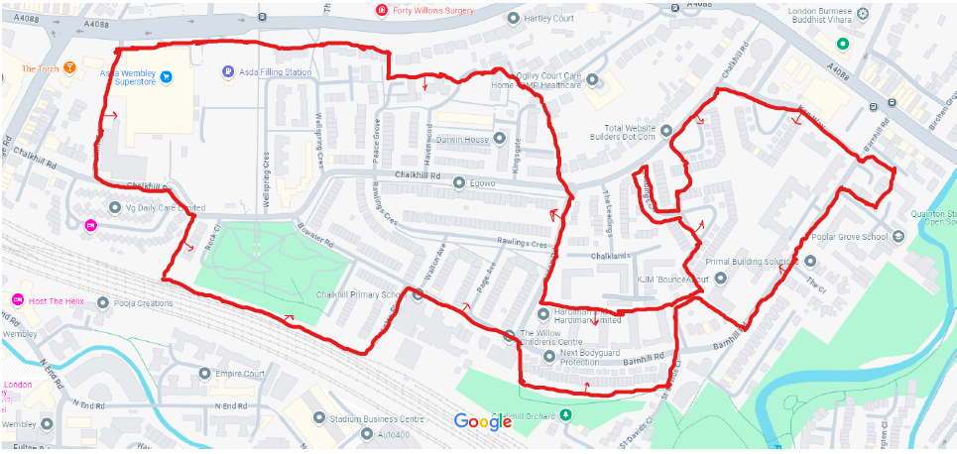
Map of the CCTF Area of Benefit

